Practical 12

Part A
1) | Word frequency: split a paragraph into words, count each in a HashMap, and print the words sorted by frequency (highest first) using a Comparator.
 | WordFrequency.java
Code | import java.util.*;  public class WordFrequency {  public static void main(String[] args) {  String paragraph = "Java is simple. Java is useful. Java supports objects."; HashMap<String,Integer> counts = new HashMap<>();  for (String word : paragraph.toLowerCase().split("[^a-z]+")) {  if (!word.isEmpty()) { counts.put(word, counts.getOrDefault(word,0) + 1); }  }  ArrayList<Map.Entry<String,Integer>> list = new ArrayList<>(counts.entrySet()); list.sort(Comparator.<Map.Entry<String,Integer>>comparingInt(e -> e.getValue())  .reversed().thenComparing(e -> e.getKey())); for (Map.Entry<String,Integer> e : list) {  System.out.println(e.getKey() + ": " + e.getValue());  }  }  }
Output | 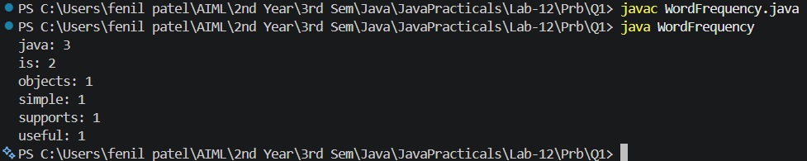

2) | Unique visitors: from a list of login names with repeats, use a HashSet to count unique users and a LinkedHashSet to keep first-seen order; print the unique count and the first three distinct names.
 | Visitors.java
Code | import java.util.*; public class Visitors {  public static void main(String[] args) {  List<String> names = Arrays.asList("Tej","Riya","Tej","Aman","Riya","Neha"); HashSet<String> unique = new HashSet<>(names);  LinkedHashSet<String> ordered = new LinkedHashSet<>(names); System.out.println("Unique users: " + unique.size());  int count = 0;  for (String name : ordered) { if (count == 3) { break; }  System.out.println(name); count++;  }  }  }

Output | 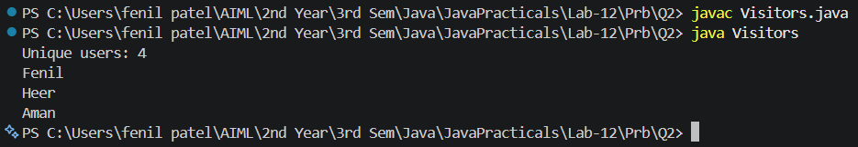

3) | (For Advanced Learners – home) Build a leaderboard from player scores held in a Map and print the top-N sorted by score (ties broken by name); choose the data and sorting details.
 | Leaderboard.java
Code | import java.util.*;  public class Leaderboard {  public static void main(String[] args) { Map<String,Integer> scores = new HashMap<>(); scores.put("Tej",90); scores.put("Riya",95);  scores.put("Aman",90); scores.put("Neha",80); ArrayList<Map.Entry<String,Integer>> list = new ArrayList<>(scores.entrySet()); list.sort(Comparator.<Map.Entry<String,Integer>>comparingInt(e -> e.getValue())  .reversed().thenComparing(e -> e.getKey())); int n = 3;  for (int i = 0; i < Math.min(n,list.size()); i++) { System.out.println((i + 1) + ". " + list.get(i).getKey()  + " " + list.get(i).getValue());  }  }  }

